**Smart Parking using IOT SYSTEM**

**TEAM MEMBER**

**Name : HEMANATHAN S**

**NM id : au411521106019**

**Phase-1 Document Submission**

## Project : Smart Parking

## IoT based smart parking system

**OBJECTIVE:**

The project involves integrating IoT sensors into public transportation vehicles to monitor ridership, track locations, and predict arrival times. The goal is to provide real-time transit information to the public through a public platform, enhancing the efficiency and quality of public transportation services.

**PHASE-1 : ABSTRACT AND MODULES**

**Abstract:**

Smart Parking using Internet of Things (IoT) is a revolutionary approach to optimize parking management systems in urban areas. Traditional parking systems often suffer from inefficiencies, leading to congestion, wasted time, and increased environmental pollution. This paper proposes an IoT-based Smart Parking solution that leverages advanced technologies to enhance the overall parking experience. By integrating sensors, communication devices, and data analytics, the system provides real-time information to drivers, allowing them to find and reserve parking spaces effortlessly. This not only reduces traffic congestion but also contributes to the conservation of natural resources. The proposed solution emphasizes efficiency, convenience, and sustainability, making it a promising candidate for modern urban planning.

**Modules of Smart Parking Using IoT:**

**1.Sensor Network:**

* Deploying various sensors such as ultrasonic sensors, infrared sensors, or cameras in parking lots to detect the presence or absence of vehicles.
* Utilizing these sensors to collect real-time data about parking space occupancy and relay the information to the central system.

**2.IoT Gateway:**

* Setting up an IoT gateway to connect the sensors with the central server.
* Implementing communication protocols (e.g., MQTT, CoAP) for seamless data exchange between sensors and the gateway.

**3.Cloud-Based Data Storage:**

* Establishing a cloud-based platform to store the collected data securely.
* Implementing a database system to efficiently manage and process real-time parking data.

**4.Data Analytics and Processing:**

* Utilizing data analytics techniques to process the collected data and generate valuable insights.
* Implementing algorithms to predict parking space availability based on historical data patterns and current occupancy.

**5.Mobile Application Development:**

* Designing and developing a user-friendly mobile application for both Android and iOS platforms.
* Integrating features such as real-time parking availability, reservation options, navigation to the parking space, and payment gateways.

**6.Parking Reservation System:**

* Implementing a reservation system that allows users to pre-book parking spaces.
* Integrating payment gateways for secure online transactions and reservation confirmation.

**7.User Notification System:**

* Setting up a notification system to inform users about parking space availability, reservation confirmation, and payment receipts.
* Implementing push notifications, SMS, or email alerts for timely communication with users.

**8.Parking Management Dashboard:**

* Creating a web-based dashboard for parking lot operators and administrators to monitor real-time parking occupancy, user reservations, and revenue generation.
* Providing graphical representations and statistical data for better decision-making.

**9.Security and Access Control:**

* Implementing security measures such as encryption and authentication protocols to ensure the integrity and confidentiality of data.
* Integrating access control mechanisms to restrict unauthorized access to the system and sensitive information.

**10.Sustainability and Environmental Impact:**

* Analyzing the environmental benefits of the Smart Parking system, including reduced fuel consumption, lower carbon emissions, and decreased traffic congestion.
* Conducting studies to measure the system's overall impact on urban sustainability and green initiatives.

**11.Maintenance and Scalability:**

* Developing a robust maintenance module to monitor the health of sensors and IoT devices in real-time.
* Designing the system architecture in a scalable manner to accommodate a growing number of parking spaces and users.

**SAMPLE PICTURES AND IDEAS OF OUR MODEL:**

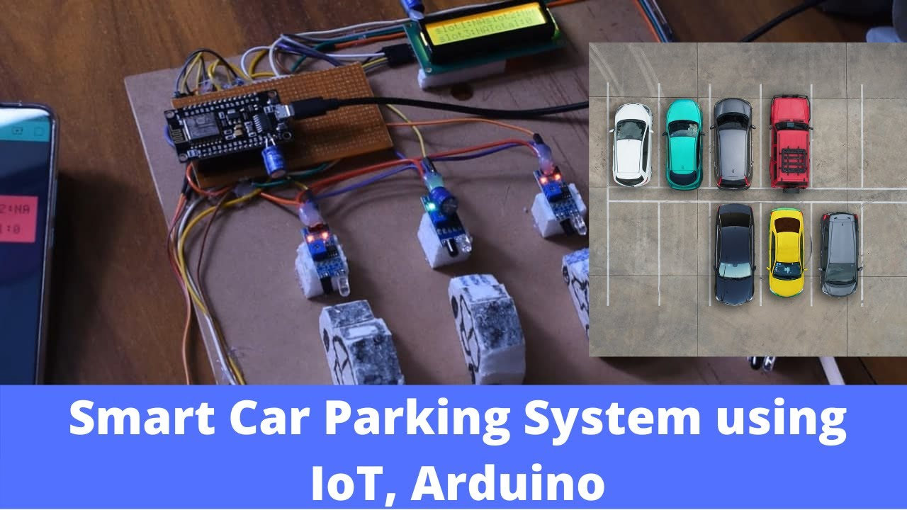

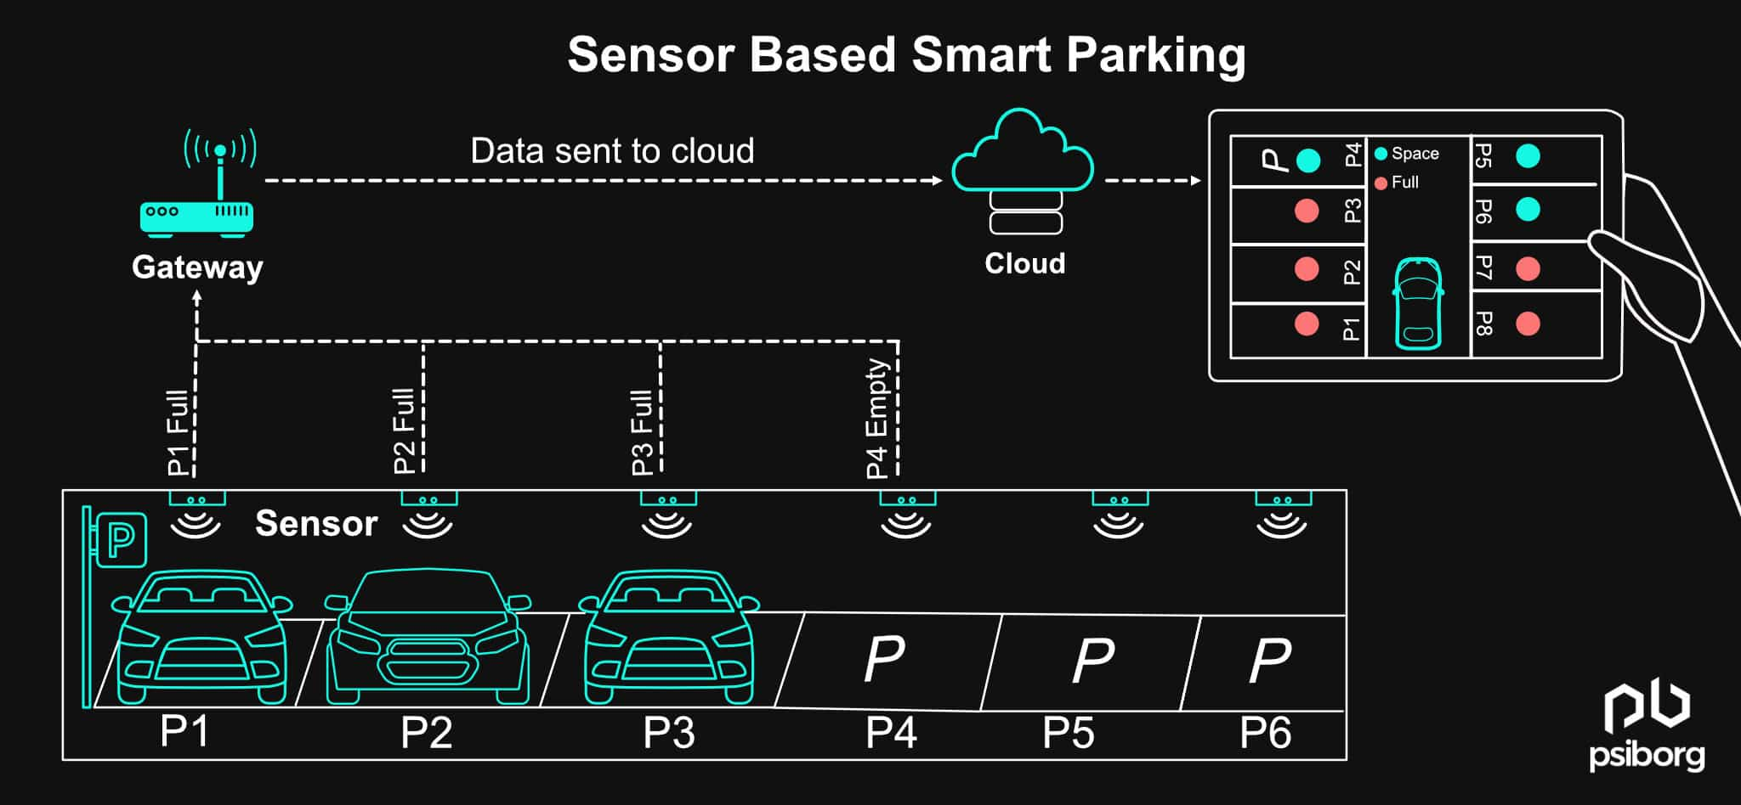

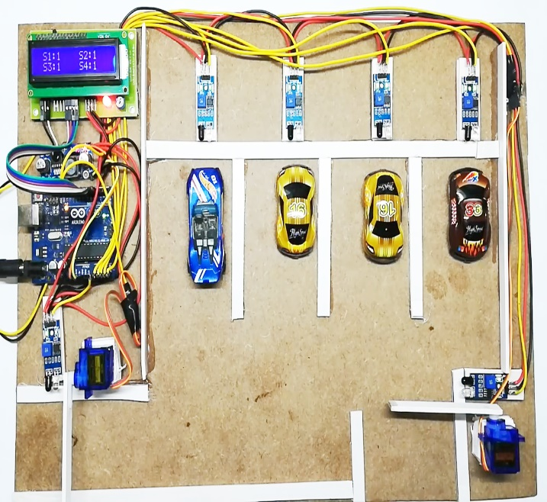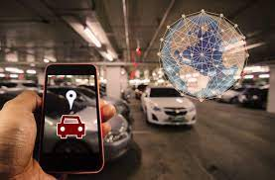

**CONCLUSION:**

By integrating these modules, the Smart Parking system using IoT offers a comprehensive solution to address the challenges of urban parking, leading to improved efficiency, reduced environmental impact, and enhanced user satisfaction.